**Unit 3 – Planning and management of computer project**

**346584 – Mohammed Mahin Ibnay Mamun**

Learning Aim, A – demonstrating knowledge and understanding of the project planning and management concepts, processes, and lifecycle.

**Project definition** – A project is a set of tasks which must be completed to arrive at a particular goal or outcome. Depending on the size and scope of the project, these tasks may be simple or elaborate, but all projects can be broken down into objectives and what needs to be done to achieve them.

**What is project management?**

**Management purpose** – The purpose of the project management is to plan, organize, budget, and control the project so it meets the needs of the customer within the constraints given.

* Provides a framework
* Broken into objectives
* Designed to meet the overall aim of the project

**Key characteristics of a project**

* **Temporary** - Every project has a start and end.
* **Unique deliverance** – produce some deliverables: product/service
* **Progressive elaboration** – continues investigation and improvements
* **Purposeful** – rationalable and measurable purchase
* **Logical** – has a certain lifecycle
* **Structured** – interdependencies between its tasks and activities
* **Limited** – by available resources
* **Risk** – as it involves an element of risk

**Key project terms to know**

* **Project lifecycle –** refers to the **5** phases all projects must follow these from start to end. **(Initiation, planning, execution, monitoring and closure**)
* **Project Scope** – key aspect of planning stage, many ways it is starting point. Determining project scope requires the project manager and the team to set goals / objectives, tasks, dates.
* **Stakeholder** – refers to everyone referred to a project. Can be involved in any stage of the project. Stakeholder analysis helps categorize how investors, team members, vendors, contractors and more can affect your project.
* **Deliverable** – refers to the specific outcome. Can be “tangible” or “intangible” = physical or not.
* **Milestones** – predetermined achievements which help track progress. Can be decided before a project begins.
* **Resources**- anything necessary to complete a project. A project manager must be able to identify all the project resources to create a resource plan and manage the resources accordingly.
* **Dependencies** – refer to how resources must be shared and allocated within a project.

**01 key factors, processes & stages of a typical computing project**

Could you take on a project knowing the deliverables, but not the budget?

No because without a budget you may not be able to get the first part of your task which would lead to not reaching the end goal.

**Costs and timescales**

**Project budget –** is a sum of money allocated to undertake and complete a task, I this case computer related. It is the amount of money that has been set aside for the entirety of the project from start to end. All projects have a budget, it will be impossible to source the right amount of people, equipment, materials.

* **client’s perspective** we mean: “how much can they afford to pay for this work to be completed?”
* **project managers perspective**: “what will it cost for this work to be completed the way we intend to do, and what will the money be used on”

A project budget aims to estimate the total cost of implementing a project, over a specified timescale. The budget must account for anything that incurs a cost during the project even if there does not appear to be a direct cost such as:

* Purchasing parts
* Paying for subcontractors
* Travel expense
* Time taken to anyone on the project through phone calls

There are 3 main components which must be considered while making a project budget:

**Manpower –** project manager will need to be paid Aswell as other members on the team. Every hour that is worked needs to be billed.

**Equipment** – because you are planning a software project that does not mean all equipment is available to you. You may need to purchase a hire specialist for the development team. This is the cost.

**Materials** – any other costs required that do not fall in the 2 other categories...

Businesses often underestimate project budgets, due to limitation of knowledge.

The project manager (PM) is responsible for planning the project and overseeing execution

**Task 2**

**Why do you think these situations arose?**

* The budget was lower than required.
* There was not enough time.
* The design did not match the overall goal.

**How could the outcome have been prevented?**

* Given more time
* Given a higher budget
* Got a better designer who is more experienced(budget)

**Setting milestones and deadlines**

To monitor and measure the progress of any project, the PM will set milestones and deadlines for achieving various stages.

Each milestone will be set in advance within a timeframe that is agreed by the team as being manageable and reasonable for the project progress.

By setting these milestones, the PM can organize resources in accordance with each stage and keep better control over the budget by buying what is necessary sufficiently in advance without buying things early.

**Deadline and interim reviews**

A **deadline** is a specified date by which a job must be finished. Meeting deadlines is crucial to the success of a project. If a task is not completed by a deadline, it may be necessary to act.

**Interim reviews** occur at predetermined intervals during the project. They enable the project manager to evaluate the project. They enable the project manager to evaluate progress and determine if project objectives are being met.

**Task 3**

Due to the reason the deadline was not met, Actions will need to be taken, for instance the project manager may need to extend it. This depends on why the project did not meet the deadline. If the cause, for example, was due to a deficiency of equipment, then the project manager should reflect on elevating the budget or replacing the equipment.

**Task 4 RECAP**

1) **List the key characteristics of a project**

Temporary

Risk

Logic

Limited

structured

2) **what are the 5 phases of the project lifecycle**

Initiation

Planning

execution

Monitoring

closure

3) **give 3 examples of stakeholders for a project**

Designer

Developers

Team members

4) **what is “deliverable.” State 3 examples**

refers to the specific outcome. Can be “tangible” or “intangible” = physical or not

**Quality and deliverables**

The success of a computer project is deepened in part in quality management, which specifies how the project accomplishes the client-agreed-upon objectives (deliverables). You must update the application of quality standards, client needs, and the product breakdown structure

**Quality standards:**

Quality assurance methods ensure that each stage of the project is achieved. The two best recognized standards are:

* ISE/IEC
* World wide web consortium W3C

**SMART**

**Specific**

Who is involved in this goal?

What do I need to achieve

**Measurable**

How much / how many?

How do I know if I reached my goals?

What is my indicator of progress?

**Achievable**

Have others done it successfully before? /No - what did they not have?

What am I missing?

Do I have the resources? /No - can I get them?

**Realistic**

Is it possible?

**Time**

Does my goal have a deadline?

By when do you want to achieve it?

**Task 1**

**S**pecific – What does David want to achieve? David wants to improve his computer game development skills and apply for game developer jobs by taking a class which will give him experience.

**M**easurable – must it happen by a certain time? David must attend every Thursday 6-8 until his exam takes place, which is in 6 weeks.

**A**chievable – is it clear how it will happen? Yes, David will attend the classes and improve his knowledge and then take an exam.

**R**ealistic – is the goal realistic? Yes, because he only has class for 2 hours on Thursday which leaves him with a lot of spare time to revise what he has learned and practiced. He also has 6 weeks till the exam so there is plenty of time.

**T**ime – when should it happen by? David has 6 weeks till his exam, until then he should attend the college game programming class every Thursday from 6-8.

**Customer requirements**

Customer satisfaction is an essential requirement for all projects and includes:

* **Functional requirements** - a function that the software is expected to provide.

-User can create an account

-Password can be reset

* **Non-functional requirements –** everything else. Anything that a client says the system should do.
  + - Accessibility
    - Capacity
    - Recovery
    - Efficiency
    - Effectiveness
    - Privacy
    - Quality

**Product breakdown structure (Pbs)**

It is a visual map that shows the relationship between components and activities

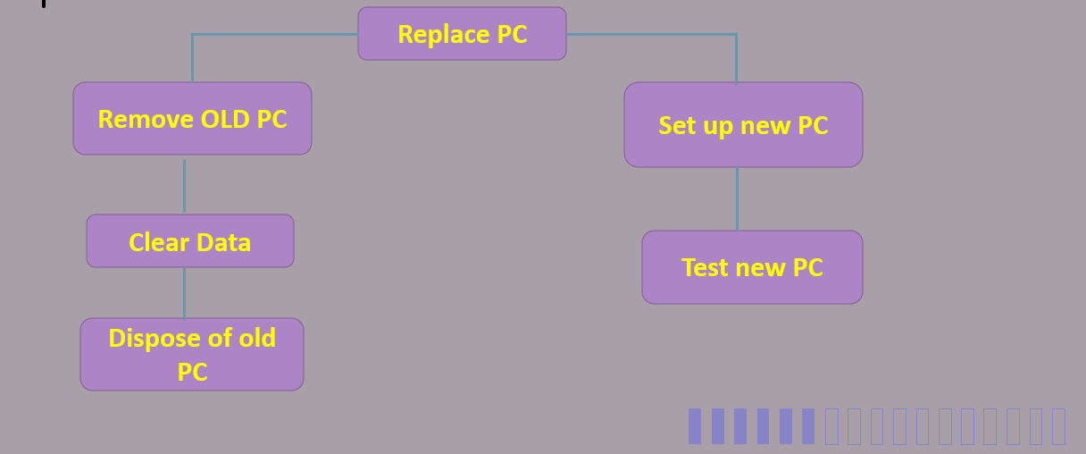

**Task 2**

* Text to speech
* Magnifying tool for images

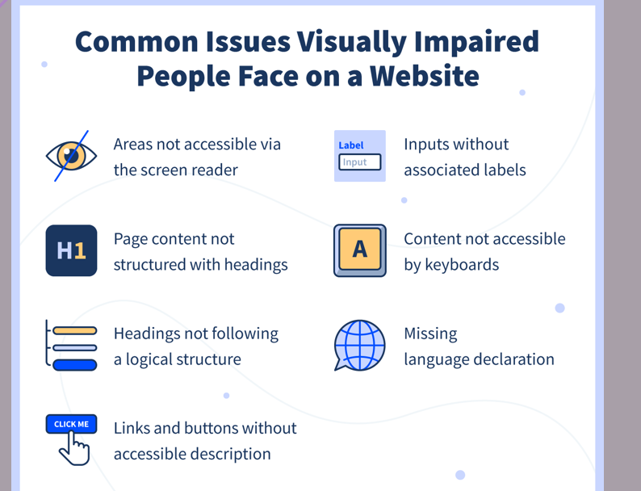



**Recap**

**What does smart stand for? Give examples of how we could make an objective smart?**

**Specific**

Who is involved in this goal?

What do I need to achieve

**Measurable**

How much / how many?

How do I know if I reached my goals?

What is my indicator of progress?

**Achievable**

Have others done it successfully before? /No - what did they not have?

What am I missing?

Do I have the resources? /No - can I get them?

**Realistic**

Is it possible?

Has it ever been accomplished before?

**Time**

Does my goal have a deadline?

By when do you want to achieve it?

**What are KPI’s and where are they used?**

(KPIs) stands for Key Performance Indicators which are critical (key) indicators of progression towards the expected outcome.

**What is PBS and where is it used?**

Product breakdown structure (Pbs) It is a visual map which shows the connection between elements and tasks

**What is the difference between a functional requirement and a non-functional requirement? Give examples.**

**Functional requirements** - a function that the software is expected to provide.

-Password can be reset

-User can create an account

**Non-functional requirements –** everything else. Anything that a client says the system should do.

Accessibility

Capacity

Recovery

Efficiency

Effectiveness

**The risk management cycle**

Planning around risks

During project planning to monitor and review progress during the project, risks must be accepted, and strategies must be agreed to mitigate these risks.

It is highly likely that the level or degree of risk will vary as the project progresses and contingency plans will need to be put in place to alleviate the risks or strategies identified to avoid the risk completely.

You cannot completely avoid all risks, otherwise nothing would ever be achieved, so risks must be identified and accepted, and contingency plans must be put in place, or the risk (if it does not outweigh the benefit) should be avoided.

**Monitor and control the risks through the project**

Throughout any project, it is important to monitor the risks that have been identified as their status will change as the project progresses. For example, if the identified risk was that passengers may not be able to check in online before flying due to a software upgrade, the risk may no longer exist after the update.

However, as a result, another risk might emerge such as the software update not being compatible with the other systems in use. Other risks will occur during the project and these risks may not have been expected during the initial planning phase.

For all known risks, a plan should be created so that, if it does happen, it can be mitigated and resolved quickly. With a plan, you can ensure that the resources are available to solve the problem when needed.

**Resource list** – a list of all staff, equipment and raw materials required for a project.

**Risk = Probability x Severity**

**5 primary ways to manage your project risks:**

1.Avoidance.

2.Acceptance.

3.Monitor and Prepare.

4.Mitigation.

5.Transference.

**Avoidance**

The easiest way of removing risk from a project. It involves the removal of the tasks that contain the risk from the project.

Sometimes you can remove a small part of a project that has a greater risk factor.

Changing the project plan to eliminate a risk involves changes in the scope, resources and/or time of the project, but this may be the right response.

**Acceptance**

Acceptance involves planning the risk into the project. If a better response strategy cannot be identified, it may be sufficient to accept the risk to continue the project.

Remember, all projects carry risk in some form. Management should be notified that there could be implications to cost/time/etc. if the risk occurs.

**Monitor and Prepare**

This response can be used for major risks that carry a high probability and/or severity but must be accepted by the project.

* Creating plans for monitoring the triggers that activate the risk.
* Building action plans that can be immediately mobilized upon occurrence of the risk.

**Mitigation**

Take measures to reduce the likelihood of a risk occurring. This is usually a preferable option to reducing the severity because it is better not to experience the risk occurrence in the first place.

Severity. Reduce the impact of the risk on the critical success factors of the project.

* Reduce complexity
* Test more
* Get more resources.
* Add time to the schedule
* Create a detailed prototype.
* Provide technical training.
* Perform more site visits.

**Transference**

You can transfer the risk onto another party. Naturally, this will usually require some form of trade-off (or cost). Shifting the consequence of a risk to a third party is not always easy but is often overlooked. Here are a few ideas:

* Purchase insurance.
* Outsource difficult work to a more experienced company.
* Remove warranties and/or guarantees